HW #7 Finite Difference Solution of the Black-Scholes Equation

0. Executive Summary
. Value of European put calculated by C-N procedure for K=$10, r=$0.05/yr, =0.20/yr, T=0.5/yr with accuracy to nearest penny.
S | V | S | V | S | V
S=1 | 8.75 | S=2 | 7.75 | S=3 | 6.75
S=4 | 5.75 | S=5 | 4.75 | S=6 | 3.75
S=7 | 2.76 | S=8 | 1.80 | S=9 | 0.99
S=10 | 0.44 | S=11 | 0.16 | S=12 | 0.05
S=13 | 0.01 | S=14 | 0.00 | S=15 | 0.00
S=16 | 0.00 | S=17 | 0.00 | S=18 | 0.00
S=19 | 0.00 | S=20 | 0.00

In addition, if we choose S=8:
V=$1.80 (accurate to the nearest penny).
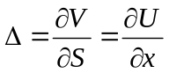=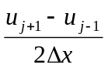=-0.908

- Statement of Problem
In order to solve the Black-Scholes Equation, we need a procedure to solve the initial-boundary-value problem. In financial field, we use Crank-Nicolson method to solve this partial differential equation.

- Description of The Mathematics
First, we have already known the initial boundary value problem for the European put is:
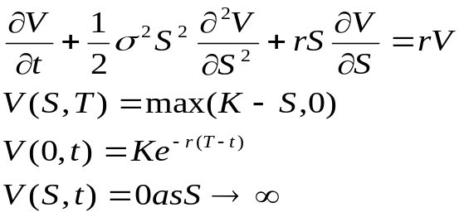
In order to solve this partial differential equation, we do the following transform:
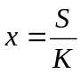, 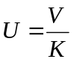, 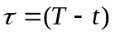, then we have equations:
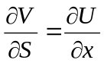, 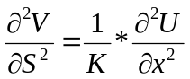, 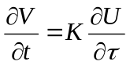
So the scaled IBVP is :
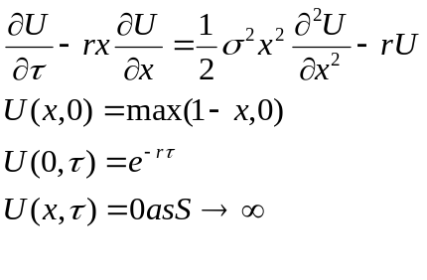
Second, we use Crank-Nicolson approximation to get the numerical solution of the problem. From previous we know how to approximate derivatives:
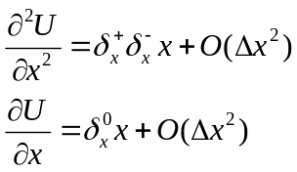
So : 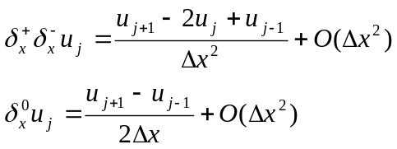
Then use Trapezoidal Rule to integrate through from 0 to T, we get following equations:
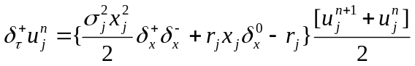
Where 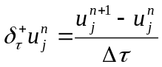
So we can represent the whole problem as:
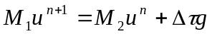
Where: 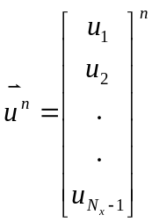, 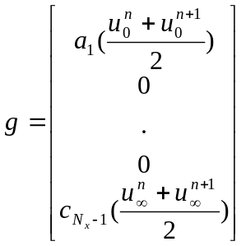
And:
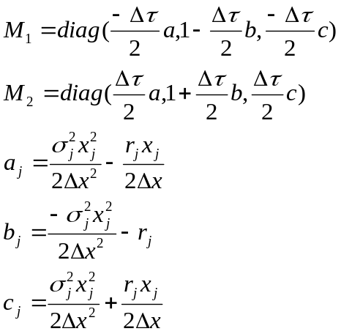

Third, we need to check the error, the method like the one we use in the Quadrature assignment. We choose two mesh with and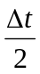. Then we have the following equations:
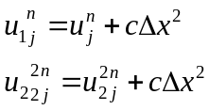
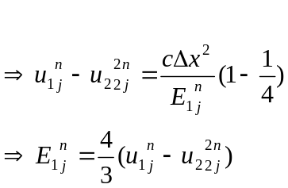

At last, in order to check the whole procedure, we have to solve a problem which we know the answer. If we add forcing term 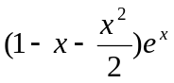to the right of the initial problem, and choose x from 0 to 2, from 0 to 1, 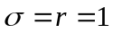. Then the exact solution of the following problem is 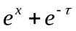
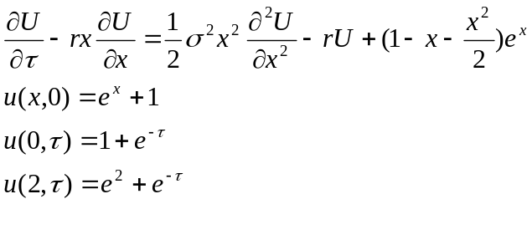

- Description of the Algorithm
Input 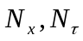
For n=0 To 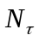-1
Compute 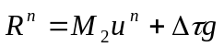
Solve 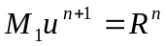 for 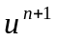
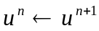
Next n

- Results
1.
Value of European put calculated by C-N procedure for K=$10, r=$0.05/yr, =0.20/yr, T=0.5/yr with accuracy to nearest penny.
S | V | S | V | S | V
S=1 | 8.75 | S=2 | 7.75 | S=3 | 6.75
S=4 | 5.75 | S=5 | 4.75 | S=6 | 3.75
S=7 | 2.76 | S=8 | 1.80 | S=9 | 0.99
S=10 | 0.44 | S=11 | 0.16 | S=12 | 0.05
S=13 | 0.01 | S=14 | 0.00 | S=15 | 0.00
S=16 | 0.00 | S=17 | 0.00 | S=18 | 0.00
S=19 | 0.00 | S=20 | 0.00
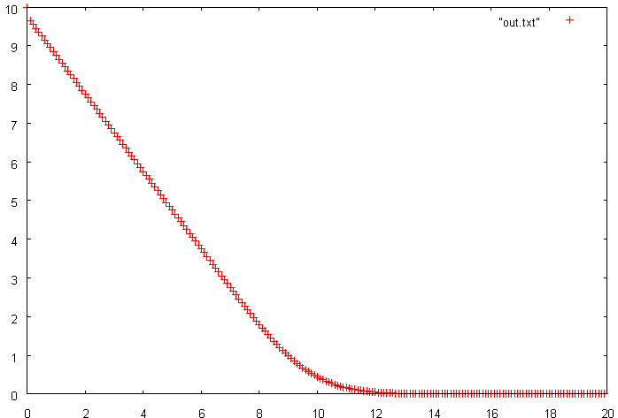

By running the procedure two times with 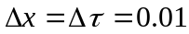 and 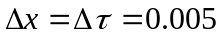, we can get the following output in which the absolute error was calculated by the equation 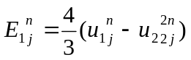. The output tells that the absolute error less than 0.001, so the output can be accurate to the nearest penny.
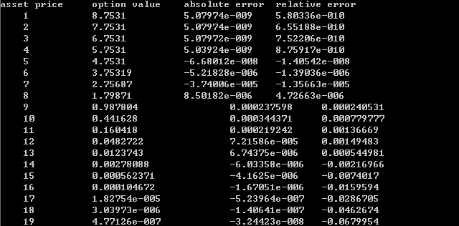

2.
Since , , then .
So choose S=8, V=$1.80 (accurate to the nearest penny).
==-0.908
3.
As in the last section, choose the point S=8 to calculate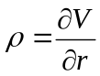
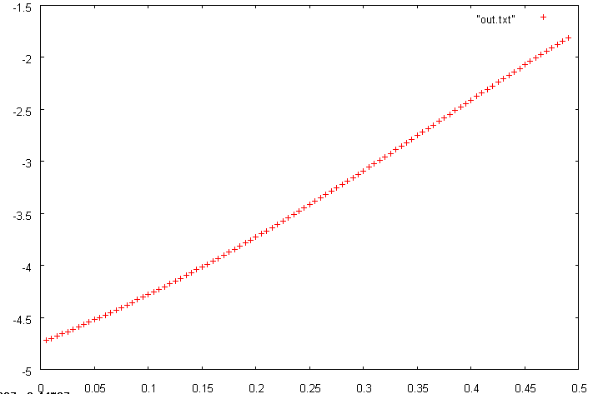
This is the graph of  value where R change from 0 to o.5.

- Conclusions
Test the procedure of solving PDE.
We choose to solve a problem whose exact solution was already known.
And choose x from 0 to 2, from 0 to 1,, then the exact solution will be . The theory tells us:
1. Error=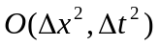. In this problem, since 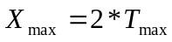, if we choose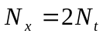, then 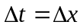 and the error calculated should be reduced to 1/100 when reduced to 1/10.
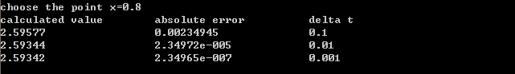
The absolute error is the numerical solution calculated by C-N procedure minus the exact solution at the point x=0.8. It follows the theory that when reduced to 1/10, the error reduced 1/100.

2. If we do the Crank-Nicholson procedure twice and choose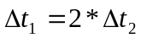. The error should satisfy the following equation
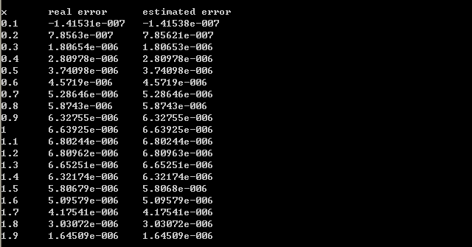
I have run the procedure twice by choosing 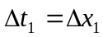=0.005 and 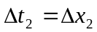=0.0025. The real error is calculated by calculated solution minus exact solution at x, and the estimated error is calculated by the equation, and these two columns match.

So the whole C-N procedure follows what the theory tells.

- Code Listing

<main.cpp>

#include "Quadrature.h"
#include <iostream>
#define _USE_MATH_DEFINES
#include <math.h>
#include <fstream>
using namespace std;

void TriDiagonal( double *A, double *B, double *C, double *R, double *U, int number)
{
for(int k=2;k<number;k++)
{
B[k]=B[k]-C[k-1]/B[k-1]*A[k];
R[k]=R[k]-R[k-1]/B[k-1]*A[k];
}
U[number-1]=R[number-1]/B[number-1];
for(int k=number-2;k>=1;k--)
{
U[k]=(R[k]-C[k]*U[k+1])/B[k];
}

}

void Payoff(double *f1,double dx, int number)
{
//=================================================payoff for the blace scholes equation
for(int k=0;k<number;k++)
{
if((1-k*dx)>0) f1[k]=1-k*dx;
else f1[k]=0;
}
/*
//==================================================payoff for the test problem
for(int k=1;k<number;k++)
{
f1[k]=1+exp(k*dx);

}
*/
}

double ForcingTerm(double x)
{
//return (1-x-pow(x,2.0)/2)*exp(x);//===========forcingterm for test problem
return 0; //===========forcingterm for black scholes equation
}

void solve(int x, int t,double r,double *f1)
{
double Smax=20.0;
//double Tmax=1; //=====================for test problem
double Tmax=0.5;
double StrikePrice=10.0;
//double Volatility=1 //======================for test problem
double RatioRate=r;
double Volatility=0.2;

int Nx=x;
int Nt=t;

double Xmax=Smax/StrikePrice;
double dx=Xmax/Nx;
double dt=Tmax/Nt;

double* U=new double[Nx];
double* A=new double[Nx];
double* B=new double[Nx];
double* C=new double[Nx];
double* R=new double[Nx];
double* F=new double[Nx];
double Xj=0;
double Tj=0;

Payoff(U, dx, Nx);

for(int p=0;p<Nt;p++)
{
Tj=p*dt;
for(int k=1;k<Nx;k++)
{
Xj=k*dx;
A[k]=(pow(Volatility,2.0)*pow(Xj,2.0)/2.0/pow(dx,2.0)-RatioRate*Xj/2.0/dx)*dt/2;
B[k]=1+((-1)*pow(Volatility,2.0)*pow(Xj,2.0)/pow(dx,2.0)-RatioRate)*dt/2;
C[k]=(pow(Volatility,2.0)*pow(Xj,2.0)/2.0/pow(dx,2.0)+RatioRate*Xj/2.0/dx)*dt/2;
F[k]=ForcingTerm(Xj);
}

for(int k=2;k<Nx-1;k++)
{
R[k]=U[k-1]*A[k]+U[k]*B[k]+U[k+1]*C[k];
}

//=====================================================================================================for Black Scholes
R[1]=2*A[1]*(exp((-1)*RatioRate*p*dt)+exp((-1)*RatioRate*(p+1)*dt))/2+U[1]*B[1]+U[2]*C[1];
R[Nx-1]=U[Nx-2]*A[Nx-1]+U[Nx-1]*B[Nx-1];

/*
//====================================================================================================for test problem
R[1]=2*A[1]*(exp((-1)*RatioRate*p*dt)+exp((-1)*RatioRate*(p+1)*dt)+2)/2+U[1]*B[1]+U[2]*C[1];
R[Nx-1]=U[Nx-2]*A[Nx-1]+U[Nx-1]*B[Nx-1]+C[Nx-1]*2*(2*exp(2.0)+exp((-1)*p*dt)+exp((-1)*(p+1)*dt))/2;
*/

for(int k=1;k<Nx;k++)
{
R[k]=R[k]+dt*F[k];
} //forcing term

for(int k=1;k<Nx;k++)
{
A[k]=(-1)*A[k];
B[k]=(-1)*B[k]+2;
C[k]=(-1)*C[k];
}

TriDiagonal(A, B, C, R, U, Nx);
}

for(int k=1;k<Nx;k++)
{
f1[k]=U[k];
}

delete [] A;
delete [] B;
delete [] C;
delete [] R;
delete [] U;
}

/*
//================================================================use previous assignment
double f1(double i)
{

return pow((M_E),(pow(i,2)*(-1)/2))/pow(2*(M_PI),0.5);
}

double real(double S, double r)
{

double T=0.5;
double K=10.0;
double R=r;
double V=0.2;

double k1=-1*(log(S/K)+(R+V*V/2)*T)/(V*pow(T,0.5));
double k2=-1*(log(S/K)+(R-pow(V,2)/2)*T)/(V*pow(T,0.5));
Quadrature a;
double pd1, pd2;
if (k1>=0) pd1=0.5+a.Adaptive(*f1,0,k1,pow(10.0,-7));
else pd1=0.5-a.Adaptive(*f1,0,-k1,pow(10.0,-7));
if (k2>=0) pd2=0.5+a.Adaptive(*f1,0,k2,pow(10.0,-7));
else pd2=0.5-a.Adaptive(*f1,0,-k2,pow(10.0,-7));
//return -1*S*pd1+K*pow(M_E,(-1)*R*T)*pd2;
return -1*K*T*exp((-1)*r*T)*pd2;
}

*/

void main()
{
ofstream out;
out.open("c:\out.txt");
/*
//================================================================================solve black scholes 1,2
double D1[200];
solve(200,50,0.05,D1);
double D2[400];
solve(400,100,0.05,D2);

cout<<"asset price"<<'\t'<<"option value"<<'\t'<<"absolute error"<<'\t'<<"relative error"<<endl;
for(int k=1;k<200;k++)
{
if (k%10==0)
cout<<" "<<10*k*2.0/200.0<<"\t\t"<<10*D1[k]<<"\t\t"<<10*(D2[2*k]-D1[k])/3.0*4.0<<'\t'<<(D2[2*k]-D1[k])/3.0*4.0/D1[k]<<endl;
}

cout<<(D1[81]-D1[79])/2.0/0.01<<endl;

for(int k=1;k<200;k++)
{
out<<10*k*2.0/200.0<<'\t'<<10*D1[k]<<endl;
}

*/
/*
//=====================================================================solve Black Scholes 3
double U[100];
double D1[200];
for (int k=1;k<100;k++)
{
solve(200,50,k*0.005,D1);
U[k]=D1[80];
}
for (int k=1;k<99;k++)
{
out<<k*0.005<<'\t'<<(10*U[k+1]-10*U[k])/0.005<<endl;
}
*/
/*
//================================================================================test problem
int test=0;
int testout=8;
cout<<"choose the point x=0.8"<<endl;
cout<<"calculated value"<<'\t'<<"absolute error"<<"\t\t"<<"delta t"<<endl;
for (int k=0;k<3;k++)
{
test=10*(int)pow(10.0,k);
double *D=new double[2*test];
double *E=new double[2*test];
solve(2*test,test,1,D);
for(int p=1;p<2*test;p++)
{
E[p]=D[p]-exp(1.0/test*p)-exp(-1.0);
}
cout<<D[testout*(int)pow(10.0,k)]<<"\t\t\t"<<E[testout*(int)pow(10.0,k)]<<"\t\t"<<1/10.0/pow(10.0,k)<<endl;
}

cout<<endl;
test=200;
double *D1=new double[2*test];
double *D2=new double[2*test*2];
solve(2*test,test,1,D1);
solve(2*2*test,2*test,1,D2);
cout<<"x"<<'\t'<<"real error"<<'\t'<<"estimated error"<<endl;
for(int p=1;p<2*test;p++)
{
if (p%20==0)
cout<<p*1.0/test<<'\t'<<D1[p]-exp(1.0/test*p)-exp(-1.0)<<'\t'<<4.0/3.0*(D1[p]-D2[2*p])<<endl;
}
cout<<endl;
*/

/*
//=================================================================test use previous assignment
for(int k=1;k<20;k++)
{
cout<<k<<'\t'<<real((double)k)<<endl;
}

for(int k=1;k<99;k++)
{
cout<<k*0.005<<'\t'<<real(8,k*0.005)<<endl;
}

*/

}

